TAX INCIDENCE

1. Tax Incidence
Tax incidence is the study of the effects of tax policies on prices and the economic welfare of individuals.
Basically: as a tax is levied what happens to prices? who pays for it?
Bottom line: In general, economic incidence $≠$ legal incidence.

2. Key Points
A. The legal burden of a tax doesn’t describe who really bears the tax (if a tax is imposed on a firm it can shift the burden of the tax by raising prices for consumer )
B. The side of the market on which the tax is imposed is irrelevant to the distribution of the tax burdens.
C. Parties with inelastic supply or demand bear taxes;

3. Model
Excise tax: a fixed nominal amount depending on quantity (e.g, $ 1 per pack).
Ad-valorem tax: based on a fraction of the price (e.g., 5% sales tax).
General reasoning for Excise tax works also for ad-valorem tax
Government levies an excise tax on good.
Some Notes:
DWL= foregone transactions? more than optimal transactions? <---> Only when Qopt <> Qmkt
Tax on consumers: Demand shifts (if possible = if elasticity > 0)
Tax on suppliers: Supply shifts (if possible = if elasticity > 0)

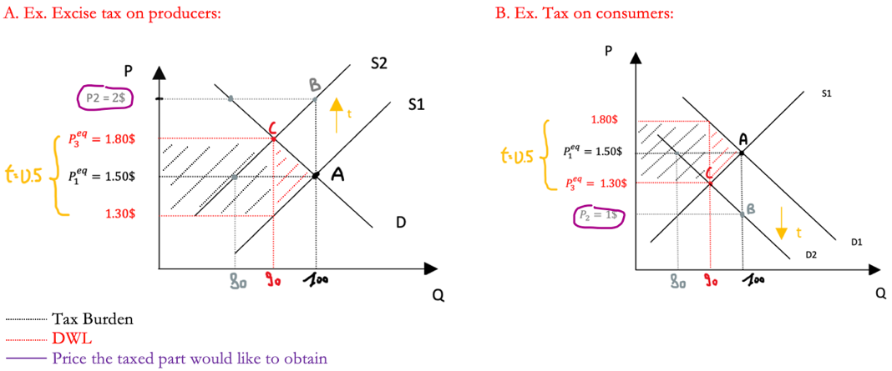

The tax burden (0.5$) was distributed between consumers (0.30$) and producers (0.20$)
Technically speaking:
i. In the first scenario the Dp is +0.30 ($P_{3}^{eq}$- $P_{1}^{eq}$ )
---> Dp for produces = +dp -t , Dp for consumers = Dp
ii. In the second scenario the Dp is -0.20 ($P_{3}^{eq}$- $P_{1}^{eq}$ )
---> Dp for consumers = –dp + t, Dp for producers = Dp

KEY: The effects are symmetrical = The side to which you apply the tax does not matter.

Each part is trying to make the counterpart pay the price of the tax. The more inelastic the part (the steepest the curve) the more tax will it bear (all about CS, PS)

Tax on producer
Ex. Inelastic Supply Ex. Elastic Supply
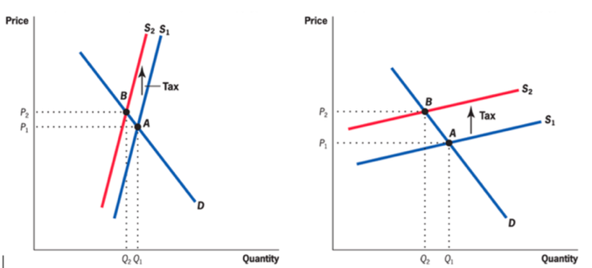

graph a) both lose, but producers lose more. Supply is more inelastic than demand. Producers do not manage to raise prices significantly.
graph b) both lose, but consumers lose more. Demand is more inelastic than demand. Producers manage to raise prices significantly.

4. Peculiar scenarios: limit elasticities

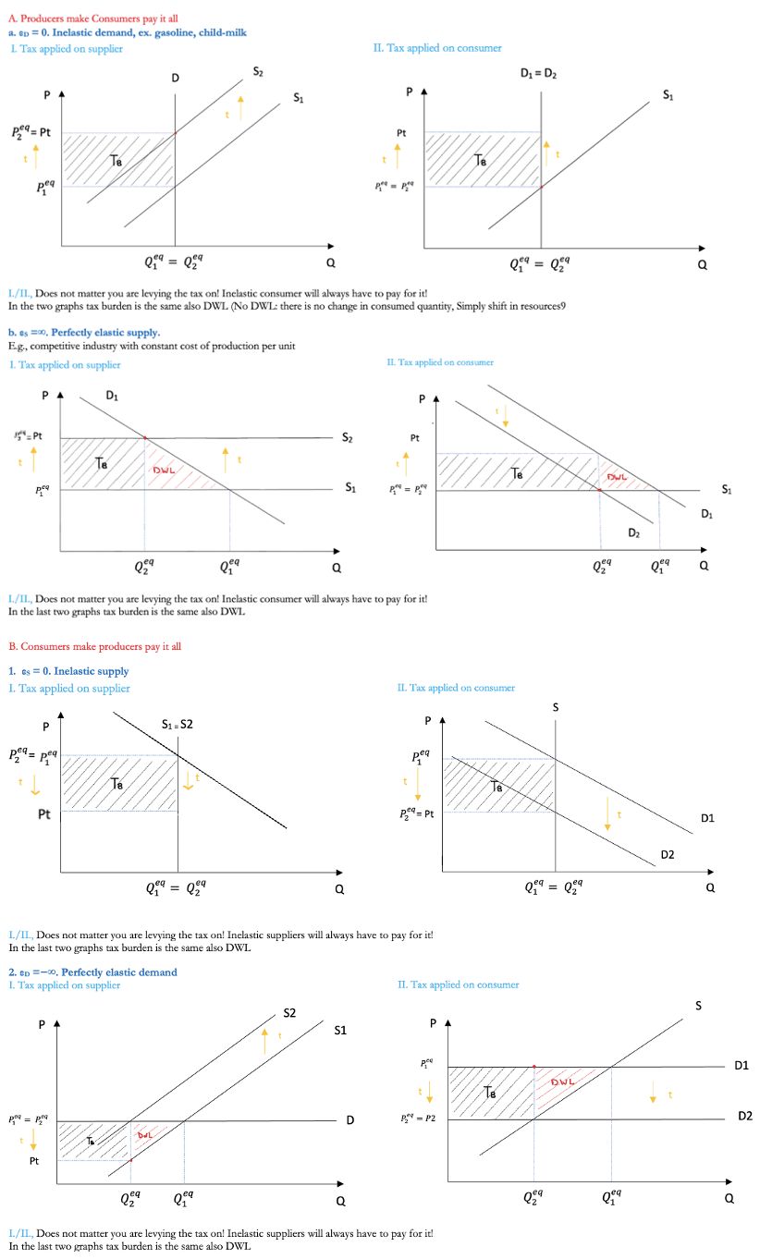

5. Effects of t on P
A. Idea
As t is applied by how much P moves? i.e. what’s the new level for $P^{eq}$?

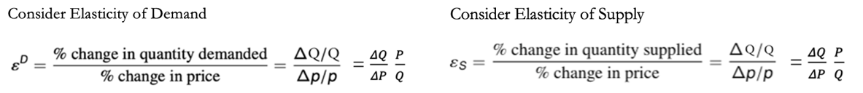

Δp for producers $≠$ Δp for consumers, the change in price is not equal for both, it is ‘subjective’ ---> that what you need to put in the formula---> then solve for the ‘common’ part dp aggregate. The two prices are different only due to the tax!!!

B. Tax on consumer
---> Dp for consumers = –dp + t, Dp for producers = Dp
dP = t * $\frac{ε_{D}}{ε_{S} - ε_{D}}$

Merge by DQ/Q the two elasticities ----> $\left(- dp + t\right) ε_{D}= dp ε_{S}$ --->

C. Tax on producer
---> Dp for produces = +dp -t , Dp for consumers = Dp
dP = t * $\frac{ε_{S}}{ε_{S}- ε_{D}}$

Merge by DQ/Q the two elasticities ----> $dp ε_{D}=(dp-t) ε_{S}$ --->

Insights: It is the relative magnitude of elasticities that determines the sign of the price increase!
Moreover, as you can see if elasticity of demand is inelastic (0) there is no price increase, consumers are not able to shift the burden on producers by shifting the price. Instead, if $ε_{D}$ > $ε_{S}$so demand is more elastic than supply we have a negative DP.

D. DWL analysis
The welfare loss of taxation is measured as a change in consumer + producer surplus minus tax collected. It is also known as the Harberger Triangle
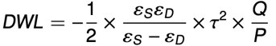
DWL = ½ * dQ * t --> recall dq is negative DWL = - ½ * dq * t
dQ/Q = ε_{S} DP/P ---> substituting DP: DQ = t * $\frac{{ε_{S} ε}_{D}}{ε_{S} - ε_{D}}$ * Q/P -->
As you can clearly see elasticities determine tax inefficiency, key points:
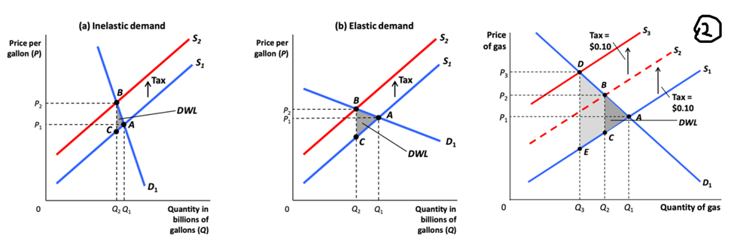
1. The higher elasticity the higher DWL
2. DWL increases with the square of t --> small tax rates have relatively small efficiency costs, large taxes have relatively large efficiency costs.
Better to have several small taxes on multiple taxes than few big taxes.
3. pre-existing distortions (existing taxes) make the cost of further taxation higher (obvious)

6. Empirical Application: If we reduce VAT ---> less inefficiency ---> higher optimal produced quantity ---> do we employ more people??
2007: In Finland, cut in VAT rate on hairdressing services (Labor Intensive factor) from 22% to 8%
Kosonen (2015) assesses the policy's effectiveness using a DiD comparing beauty salons and hairdressing.
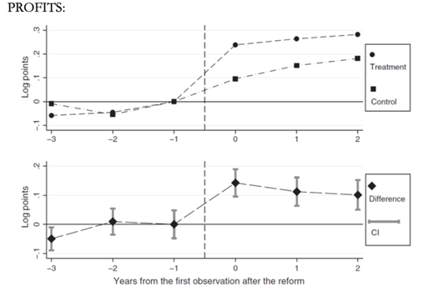
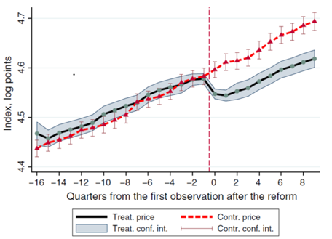
Key Findings:
a. Pass-through estimated around 50%, business kept 50%: huge reduction in cost, but hairdressers actually did not reduce prices by the full amount they are gaining in costs but by 50%
b. No effect on employment but a large increase in profits...

7. General Equilibrium Tax Incidence
Examples so far have focused on partial equilibrium incidence which considers impact of a tax on one market in isolation.
General equilibrium models consider the effects on related markets of a tax imposed on one market (especially for substitute/complementary goods or along the Supply Chain)

